How to increase the chances of Cal State LA students in getting employment

Lee, Jae Hoon

California States University of Los Angeles

April 11, 2020

BUS-3050

Professor, Rhonda Albey

Table of Contents

**Executive Summary** 4

Introduction 5

1. Statement of The Problem 6

1.1 Cal State LA Alumni Employment Status 6

1.2 Facing Barriers 7

1.3 Success in the job market affects college ranking 9

2. Background Study 9

2.1 Application Tracking System (ATS) 9

2.2 How ATS work 10

2.3 Broken System 11

2.4 Implication of ATS with Cal State LA Alumni 11

3. Case Studies 12

3.1 Unpaid-internship vs Paid-internship 12

3.2 Employment During College and Volunteers 14

3.3 GPA 14

3.4 LinkedIn Learning Certification 14

4. Solution 15

4.1 Curriculum 15

4.2 Career Center 15

5. Cost Analysis 17

5.1 Individual Level 17

5.2 Career Center & Curriculum Innovation 17

6. Research Method 17

Conclusion 18

Reference 19

List of Figures

[Figure 1: Employment Status by GALLUP 6](https://csula-my.sharepoint.com/personal/jlee464_calstatela_edu/Documents/CSULA/BUS%203050/Group%20Project/How%20to%20increase%20the%20chances%20of%20CalState%20LA%20students%20in%20getting%20employment.docx#_Toc37616440)

Figure 2: How long did it take for a good job by GALLUP 6

Figure 3: How reputation affects hiring decision by Industry by Thompson, D. 7

Figure 4: Relative Importance of Attributes in Evaluating Graduates for Hire by Thompson, D 8

Figure 5: Relative Importance of Attributes in Evaluating Graduates for Hire by Industry by Thompson, D. 8

Figure 6: Jobscan result with CSULA Career Center sample resume format 12

Figure 7: CSULA Students Career Center Usage 16

**Executive Summary**

Anananan

# Introduction

A vast majority of students see attending college as a investment for a better future. “A recent survey conducted by Higher Education Research Institute on hundreds of thousands of entering freshman found that 88% of freshman [*sic*] attend college to get a good job while 81% state the desire to be very well off financially as one of their personal goals” (Kapur, Lytkin, Chen, Agarwal, & Perisic, 2016). According to Cal State LA 2018 Undergraduate Alumni Scorecard, only 64% of Cal State LA alumni are employed with a full-time job as compared to college graduates on a national level. That is 7% below average. The lower employment rate is due, in part, to their lack of understanding in how to make their resumes attractive to prospective employers.

We are on the verge of the fourth industrial revolution. It is not surprising that many companies are already using Application Tracking Systems (ATS). ATS “helps companies organize candidates for hiring and recruitment purposes. These systems allow businesses to collect information, organize prospects based on experience and skill set, and filter applicants” (Hudson, 2019).

Cal State LA needs to innovate its curriculum and career centers to improve student employment. It's not just for students, it's also important for Carl State L.A. because the employment rate of graduates has a big impact on school rankings.

The intent of this business solution is to improve the resources offered to students and Cal State LA graduates to find paid internships and/or employment so that students can properly allocate their time and energy to projects that will be relevant to them in the professional realm.

# Employment Status for Cal State LA alumni (64% employed full time) versus College graduates nationally (71% employed full time) versus HSI graduates nationally (69% employed full time).Statement of The Problem

Figure : Employment Status by GALLUP

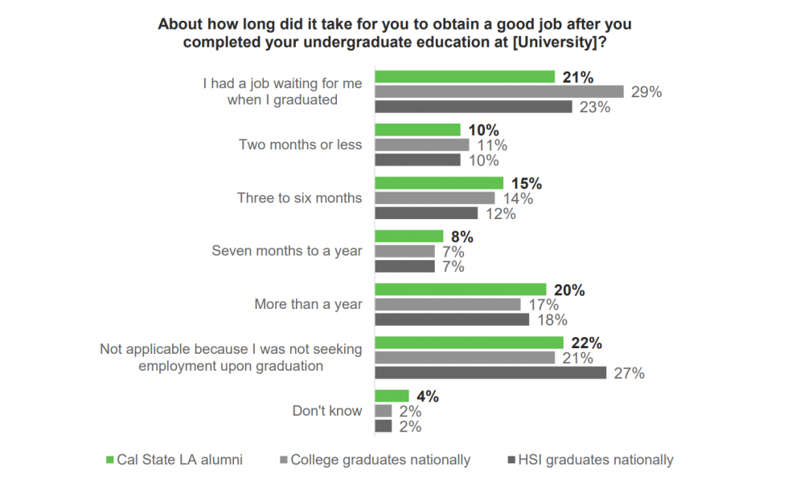

Figure 2: How long did it take for a good job by GALLUP

## 1.1 Cal State LA Alumni Employment Status

As shown in Figures 1 and 2, the employment rate of Cal State L.A. graduates is 7% lower than the national average. It can also be seen that students seeking jobs within six months are 5% below the national average. Also, it can be seen that 20% of Cal State LA alumni take more than a year to have full time jobs, which is higher than the national average of 17%. These charts show that Cal State graduates have a lot of difficulties in their employment.

## 1.2 Facing Barriers

Employers take many things into account when hiring employees with college reputation, college GPA, the relevance of coursework, extracurricular activities, volunteer experience, college major, employment during college, and internship.

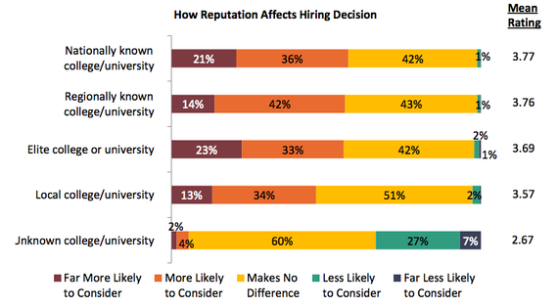There is a traditional myth for those preparing for a job. It is a school reputation. People think students in the best schools or ivy leagues get a high chance for jobs. However, as shown in the chart below, the impact of school names on employment is not significant. Also, Cal State LA is a regional college. If so, the school reputation of Cal state LA has no significant impact on employment rates.

As shown in the two charts below, internship and employment during college are the most important. School reputation is at the bottom. If so, Cal state L.A. graduates have problems with internships and employment during college that can be considered as facing obstacles in the job market. The following chart shows the industry preference for each factor.

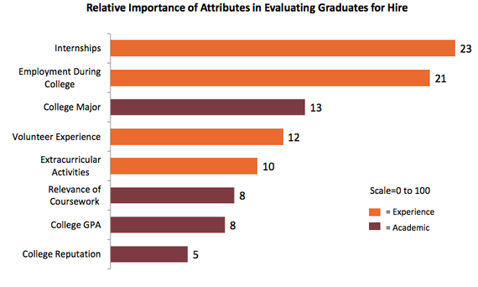

Figure 4: Relative Importance of Attributes in Evaluating Graduates for Hire by Thompson, D

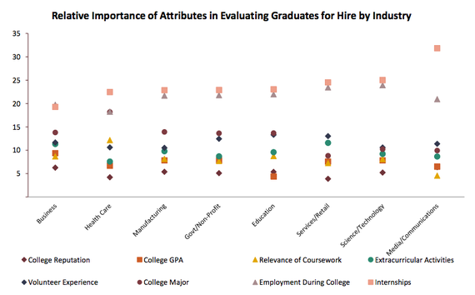

Figure 5: Relative Importance of Attributes in Evaluating Graduates for Hire by Industry by Thompson, D.

## 1.3 Success in the job market affects college ranking

Traditionally, college ranking was measured by “Learning environment, teaching and research excellence, as well as financial returns on investment in education, are important factors to consider when evaluating educational opportunities” (Kapur, Lytkin, Chen, Agarwal, & Perisic, 2016).

However, the recent trend of college ranking that the employment rate of graduates influences the college rankings. According to COLLEGECHOICE, the success of graduates in the post-college job market is 25% of the ranking system. Also, Forbes weights post-graduation success as 32.5% of college ranking. LinkedIn also, employment of alumni is an important factor to rank college. “We, therefore, derive a university success score based on the proportion of graduates who obtained employment in a given profession at some of the most desirable companies for that profession” (Kapur, Lytkin, Chen, Agarwal, & Perisic, 2016). As an institutional basis for success, it is important for Cal State to increase its rankings as well. Students, unlike employers, look to college rankings when applying to school. The increase in the employment rate of students is not only beneficial to students. It is beneficial to Cal State LA.

# Background Study

## 2.1 Application Tracking System (ATS)

“Applicant tracking systems (ATS) are software used by companies to assist with human resources, recruitment, and hiring needs. There are hundreds of ATS companies on the market and are primarily used to help collect and organize large volumes of applicants” (Qu, 2019). ATS is used by many companies. Given that 17% of the job is provided by Fortune 500 companies. Also, more than 99% of Fortune 500 companies use ATS due to convenience and cutting operational costs, and even small companies also use ATS. Big companies received thousands of applications weekly.

An applicant tracking system can also allow recruiters and hiring managers to see all the information and metrics they need with a click of a button. The best systems include robust, user-friendly dashboards and configurable workflows which include key performance metrics and industry benchmarks (Hudson, 2019).

## 2.2 How ATS work

The problem is that the main criterion for determining the system is how to write resumes, not resume contents. However, surprisingly, many job seekers are not aware of this. “The best applicant tracking systems use the latest technology, such as natural language processing and artificial intelligence to screen and sort candidates’ resumes. These systems scan resumes, looking for keyword matches and use other algorithms for data analysis” (Hudson, 2019).

What's more shocking is that 75% of applications are discarded by ATS, not by the human (Renzulli, 2019). In other words, if the applicant's resume does not pass the first gateway as ATS, the probability that a person directly reads it is close to 0%. Now we live in an era where machines judge people, not people judge people. Of course, it is a person who develops and trains the algorithm of ATS, but in the end, if the machine cannot be beaten, it is a reality that it is almost impossible to find a good job. Overall 40% of company in the United States use ATS, not thinking about ATS is like giving up the 40% job market.

If you are applying to a role at a mid- to large-sized company, chances are that you’re applying through an applicant tracking system. ATS are necessary for organizations receiving applications across multiple job openings. Rather than manually reviewing each resume, recruiters and hiring managers can opt to sort, filter, or rank candidates through their company’s ATS. If a resume doesn’t contain the right search terms or is not optimally formatted, it could get “lost” in the system, seemingly ending up in a black hole. Even if a candidate is highly qualified for the job, if they don’t have the right keywords on their resume, they might not be found (Qu, 2019).

In any case, the final purpose of the resume is the final checker. If the resume passes through the system, the person will review the resume and it is the person, not the system, who decides whether or not to hire the final job. Applicants say they spend an average of 3-4 hours rewriting keywords each time they apply. However, the person who finally reviews the resume ends the review in six seconds on average (Augustine, n.d.).

## Broken System

The applicant tracking system is never perfect. According to the CareerArc/Future Workplace survey, 62% of companies using the ATS admitted, " some qualified candidates are likely being automatically filtered out of the vetting process by mistake" (Bell, 2018)

That's ridiculously high from a job seeker's point of view. While it is true from a company's point of view that it is necessary to assist with automation in order to detect a large number of applicants, poor systems are a problem for both job seekers and job seekers. Responsibility for solving the problem rests with job seekers unless there is a significant change in the way these companies are employed.

## 2.4 Implication of ATS with Cal State LA Alumni

Given the fact that the employment rate of Cal State LA alumni is poor, it may find that many students don't know what ATS is, or have trouble writing resumes to pass ATS. As an example, I wrote a resume with samples provided by the Career Center. However, as a result of simulation at Jobscan, my resume received 13 points. This was shocking for me. Next, I tried again with the help of professors. However, my resume still scored 19. This result implies that Cal State LA students have a lot of difficulty in passing the ATS with a resume form they learn in the school's curriculum and a resume sample from the Career Center. Even I applied more than 50 applications, I did not receive a single interview request with a GPA above 3.8. This is an example of how the ATS acts as a great barrier.

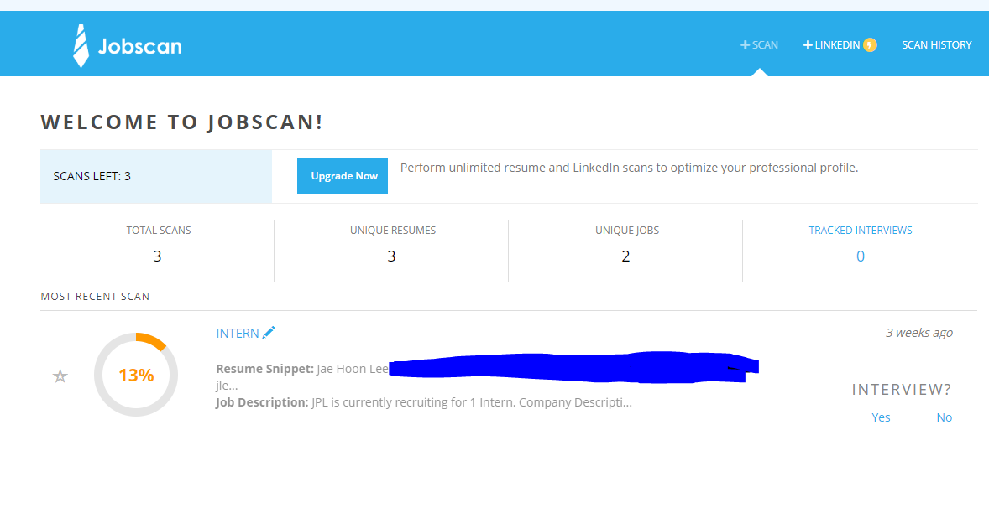

Figure 6: Jobscan result with CSULA Career Center sample resume format

# 3. Case Studies

## 3.1 Unpaid-internship vs Paid-internship

As we have seen above, we can see that internship is the most important factor in employment. However, the first step in getting an internship is for the applicant's resume to pass the ATS.

Here is a question. Do unpaid and paid interns have the same weight from the employer's perspective? The correct answer is no. I think many people exchange experiences with unpaid interns. However, in reality, they are treated so differently.

Although internships are there for students to gain experience and hopefully land a job within their career field, those who have taken an unpaid internship are less likely to receive a job offer than those who have taken a paid internship.

The impact of internship pay status was evident as well as 66.4 percent of According to NACE, 66.4 percent of class of 2019 graduates who had a paid internship received a job offer. On the other hand, just 43.7 percent of unpaid interns were offered a job. In other words, if you only graduate with an unpaid internship and your friend graduates with a similar but paid internship, she is 34 percent more likely to receive at least one job offer upon graduation. Ouch (Rothberg, 2019).

In other words, there is a huge gap between employment for paid and unpaid interns. Those who have the advantage of working as a paid intern also have better opportunities of receiving job offers, rather than unpaid interns where the percentage of them receiving a job offer is very low.

Something is interesting between unpaid interns and people who have no internship experience. According to the National Association of Colleges and Employers (NACE) 2013 survey, found that 63.1 percent of paid interns receive at least one job offer, compared to only 37 percent of unpaid interns and 35.2 percent of those without an internship. Paid interns, per these results, are offered jobs more often than unpaid interns, and even more intriguing is that unpaid interns are not much better off than those who do no internships (37 vs 35.2 percent job offer rates) (Kisakye, 2016). It means that applicants who have unpaid internships and no internships are treated similarly when they try to find a job. From an employer's point of view, unpaid interns are considered as having no internship experience.

## 3.2 Employment During College and Volunteers

As shown in Figure 4 above, it can be seen that employment and volunteer experience during the semester has a large impact on employment. This shows that employers prefer applicants with hands-on experience rather than book smart.

The Corporation for National and Community Service, a federal agency that promotes volunteerism, tracked more than 70,000 jobless people between 2002 and 2012 and found that those who volunteered had a 27% better chance of finding a job than those who didn’t (Collamer, 2013)

## 3.3 GPA

As shown in Figure 4 above, it can see that the GPA is second from the bottom. However, this does not mean that GPA is not important. Most people would say that anything below a 3.5 / 4.0 in the U.S., is a low GPA. In traditional investment banks, GPA 3.8 from unnamed universities is treated by ATS as GPA 2.0 from Harvard University (Chesare, 2018).

## 3.4 LinkedIn Learning Certification

LinkedIn Learning is an online educational platform that helps you discover and develop business, technology-related, and creative skills through expert-led course videos. As mentioned earlier, ATS does keyword searches. Cal State LA offers LinkedIn Learning for free during the school year. Complete several major-related certificates on LinkedIn Learning, and fill them out on your resume. For example, the company advertised that they prefer Tableau and R. ATS searches for keywords in Tableau and R on resumes. This greatly increases the probability of employment.

# 4. Solution

## 4.1 Curriculum

The speed at which the world's technology develops is changing at an unprecedented rate. In response, Cal State LA needs to innovate. However, the Cal State LA Business Curriculum does not focus heavily on ATS. Because of the corona crisis, although I asked five people, three did not know anything about ATS. One said that he had heard something similar. Only one person knows exactly what ATS is. Students will write a resume as a business class assignment. If it doesn't pass the ATS, it's dead education. This does not simply mean that changes must occur at the level of individual professors. Cal State LA has a Department of Computer Information System (CIS). CIS is a business and economic college. You need to understand ATS by collaborating with business professors and CIS professors and research how to deal with it. Also, this should be reflected in the class. If you don't adapt to change, you will fall. As an example, Microsoft is a powerful computer OS. However, they ignored the potential when the smartphone world opened up. As a result, Android OS and iOS dominate the smartphone OS. Microsoft jumped in late and withdrew due to sluggish business. Because of this, Microsoft was once recognized as a company with no future value. Microsoft's resurgence was revived by Microsoft officed's subscription economy and cloud computing. However, the number one cloud computing is Amazon. Like this, if a giant company called Microsoft cannot change rapidly in the times, I have seen a crisis come. Now we are in a period of the fourth industrial revolution. If Cal State LA's curriculum doesn't change accordingly that harms both universities and students.

## 4.2 Career Center

It can be seen that Cal State LA students visit the Career Center and the frequency of visits is lower as 43% than the national average of 66%. Even though how good sources are prepared, it will useless if it is not well promoted to the students. It needs to encourage students to visit the Career Center and get help.

Also, as mentioned in 2.4 Implications of ATS with Cal State LA Alumni, the career center's resume sample showed that it was difficult to get a good score in ATS. Career centers offer good seminars, many experts come and review resumes, but the center itself needs to provide students with more professional help and ATS friendly resume samples.

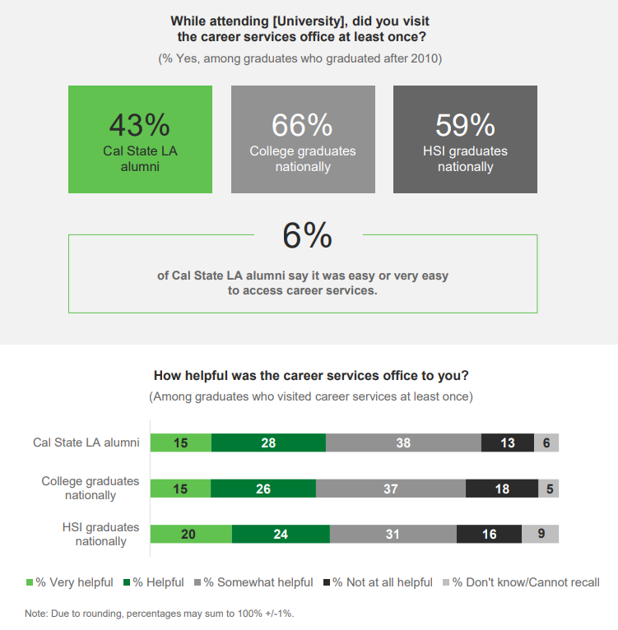

Figure : CSULA Students Career Center Usage by GALLUP

## 4.3 ATS Friendly Resume Writing

# 5. Cost Analysis

## 5.1 Individual Level

Job seekers should learn to write their resumes in ATS in Friendly format. There are many free and paid services for ATS friendly resume. Free services include ResumeWorded, TopResume, Ladders, SkillRoads, ZipJob, TheResumeCenter, EmploymentBoost, LiveCareer, Monster, Jobscan and ExpertResumes.

These free sites review and score your resume. If you are upgrading to a paid service, we also offer resume writing. For example, TopResume, full service is provided for $ 349, including resume, cover letter, and LinkedIn profile. This is not a small cost. Cal State LA can discount these prices through contracts with them.

## 5.2 Career Center & Curriculum Innovation

Universities can help students write their resumes by hiring professional resume writers or by outsourcing these resume agency services from the Career Center.

It will depend on how much your budget is, but let's plan on about $ 1,000,000 a year. As of 2015, Cal State LA enrolled 27,681 students. In this case, the tuition for one year will increase to less than $40.

With the increase in tuition of about $40 per year, students are provided with better services for employment, and even if the employment rate of alumni rises to the national average, it is worth trying enough.

# 6. Research Method

I cited data revealed on the school's website to investigate low employment rates of Cal State LA graduates. I quoted Google Scholar, News and various interviews to investigate ATS. I used NACE data to research internships, the most important factor in employment. I also researched how volunteering has a positive impact on employment.

# Conclusion

We researched the role of ATS in the fast-changing job market and the results. The employment rate of students in college also has a large impact on school rankings. For the school's reputation, it is important to increase the employment rate of students. In addition, students lose their motivation to continue their studies if they do not work well. To address this, Cal State LA found it necessary to innovate its educational curriculum and career centers. Please remember. The first step in increasing the employment rate is writing a resume to pass ATS.

# Reference

Augustine, A. (n.d.). How to pass the 6-Second resume test. Retrieved from https://www.topresume.com/career-advice/how-to-pass-the-6-second-resume-test

Bell, T. (2018, April 17). The secrets to beating an applicant tracking system (ATS). Retrieved from https://www.cio.com/article/2398753/careers-staffing-5-insider-secrets-for-beating-applicant-tracking-systems.html

Borsellino, R. (2017, August 11). Get your resume past the robots and into human hands. Retrieved from https://www.themuse.com/advice/beat-the-robots-how-to-get-your-resume-past-the-system-into-human-hands

Chesare, B. (2018, May 23). Low GPA investment banking: How to overcome low grades. Retrieved from https://www.mergersandinquisitions.com/low-gpa-investment-banking/

Collamer, N. (2013, June 24). Proof that volunteering pays off for job hunters. Retrieved from https://www.forbes.com/sites/nextavenue/2013/06/24/proof-that-volunteering-pays-off-for-job-hunters/#1472c211753a

GALLUP. (2018). California State University, Los Angeles 2018 UNDERGRADUATE ALUMNI SCORECARD.How college rankings work. (2014, September 30). Retrieved from https://www.collegechoice.net/how-college-rankings-work/

Hu, J. (2016, September 9). What you should know about the resume robots. Retrieved from https://www.themuse.com/advice/3-things-you-should-know-about-the-robots-reading-your-resume-but-dont

Hudson, K. (2019, June 26). What is an applicant tracking system? Retrieved from https://www.jobvite.com/recruiting-process/what-is-an-applicant-tracking-system/

Kapur, N., Lytkin, N., Chen, B., Agarwal, D., & Perisic, I. (2016). Ranking universities based on career outcomes of graduates. *Proceedings of the 22nd ACM SIGKDD International Conference on Knowledge Discovery and Data Mining - KDD '16*. doi:10.1145/2939672.2939701

Kisakye, J. (2016, November 2). Paid versus unpaid internships- Catch 22? Retrieved from https://www.snih.org/paid-versus-unpaid-internships-catch-22/

Kerri Anne Renzulli. (2019, March 14). 75% of resumes are never read by a human—here's how to make sure your resume beats the bots. Retrieved from https://www.cnbc.com/2019/02/28/resume-how-yours-can-beat-the-applicant-tracking-system.html

Pang, A. (2019, February 13). Top 10 applicant tracking systems software vendors and market forecast 2018-2023. Retrieved from https://www.appsruntheworld.com/top-10-hcm-software-vendors-in-applicant-tracking-market-segment/

Pardo-Bunte, M. (2020, April 8). How much do applicant tracking systems cost? 2020 pricing guide. Retrieved from https://www.betterbuys.com/ats/ats-pricing-guide/

Qu, L. (2019, November 11). 99% of fortune 500 companies use applicant tracking systems (ATS). Retrieved from https://www.jobscan.co/blog/99-percent-fortune-500-ats/

Recruiter, C. (2019, May 27). Paid vs unpaid internships are key to landing a well-paying job upon graduation - College Recruiter. Retrieved from https://www.collegerecruiter.com/blog/2019/05/27/paid-vs-unpaid-internships-are-key-to-landing-a-well-paying-job-upon-graduation/

Thompson, D. (2014, August 19). The thing employers look for when hiring recent graduates. Retrieved from https://www.theatlantic.com/business/archive/2014/08/the-thing-employers-look-for-when-hiring-recent-graduates/378693/

ZILLMAN, C., & JONES, S. (2015, June 13). Fortune 500: Companies with the most employees. Retrieved from https://fortune.com/2015/06/13/fortune-500-most-employees/